TV Lift Cabinet Guide
Tools Used:
- Drill
- Table Saw (Circular Saw)
- Nail Gun
- Electric Sander
- Miter Saw
- Concealed hinge jig
- Right angle clamp
Materials Used:
- (2) ¾” 4x8 plywood sheet
- (1) 1.5x30” piano hinge
- (1) Pack ¾” dowels
- (6) 1” x 4ft trim
- 1.25” screws
- 1.25 nails
- Wood filler
- 220-grit sandpaper
- (4) concealed hinges
- TV lift

Cut List:
Remember to measure as you go so that your cuts are more accurate. The following cut sizes are for the TV lift I bought as well as the specific TV I am using.
Name | Board Size | Quantity | Length (inches)
Top (once cut, cut in half) | ¾” plywood | 1 | 32x20 1/8
Bottom | ¾” plywood | 1 | 30.5x20
Sides | ¾” plywood | 2 | 30x20
Back | ¾” plywood | 1 | 30.5x20
Doors | ¾” plywood | 2 | 30.75 x 16
Shelves | ¾” plywood | 2 | 27 x 6
Shelves Fronts | 2in x 4ft | 2 | 27
Faux Back | ¼ x 4ft plywood | 1 | 30.25x29.25
Faux Back Supports | 1” x 2” | 2 | 29.25
Door Trim (Outside Vertical) | 1” x 4 ft trim | 4 | 30
Door Trim (Outside Horizontal) | 1” x 4 ft trim | 4 | 17
Door Trim (Inside Vertical) | ¼” x 3 ft trim | 4 | 27
Door Trim (Inside Horizontal) | 1/4” x 3 ft trim | 4 | 17
Side Trim (Outside Vertical) | 1” x 4 ft trim | 4 | 30.75
Side Trim (Outside Horizontal) | 1” x 4 ft trim | 4 | 13
Side Trim (Inside Vertical) | ¼” x 3 ft trim | 10 | 27.75
Side Trim (Inside Horizontal) | ½” x 3 ft trim | 2 | 13

Assembly Process:
Step 1: Cut the materials to size preferably using a table saw. If no table saw is available use a straight edge that is as long as the piece you are cutting and clamp it down. Then using a circular saw butt the edge of the scroll saw against the straight edge to get a straight cut.
Step 2: Once done cutting the materials use an electric sander with medium grit to remove any slivers or to clean any the of the cut pieces.
Step 3: Using a nail gun and screws, assemble the sides, back, and bottom. Start by attaching one of the side pieces to the bottom piece. Then attach the back. There should be a gap from the top of the sides to the back piece to allow space for the piano hinge to allow the top of the cabinet to open and close. Once the back is attached, attach the second side to both the bottom and back.
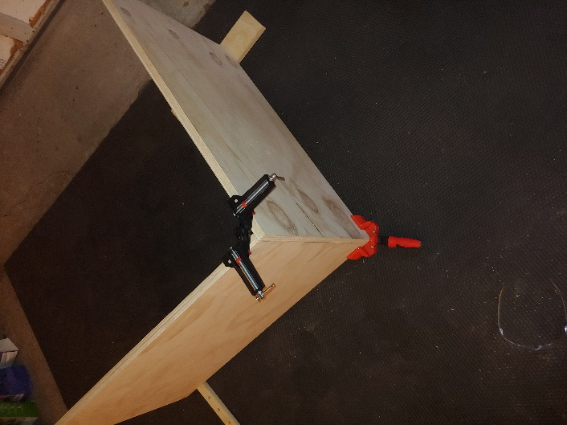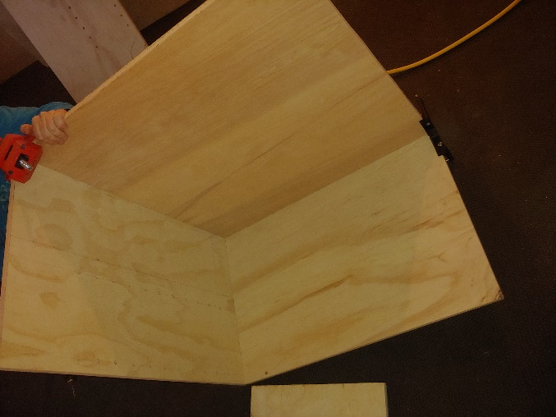
Step 4: Attach the faux back supports on each side to the inside of the cabinet sides 10 ¼ -inches from the back. Use the 1 ½ -inch nails in a nail gun and attach the supports from the outside. Set the faux back against the supports and using a pencil draw a line marking how where the faux sits on the sides. Clean up the line using a straight edge.
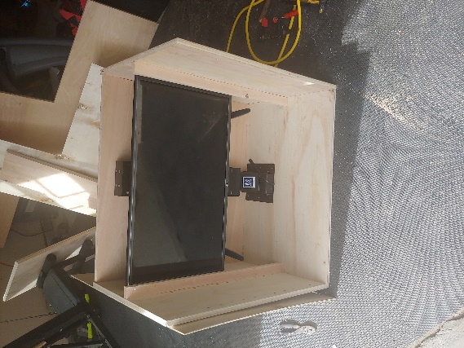
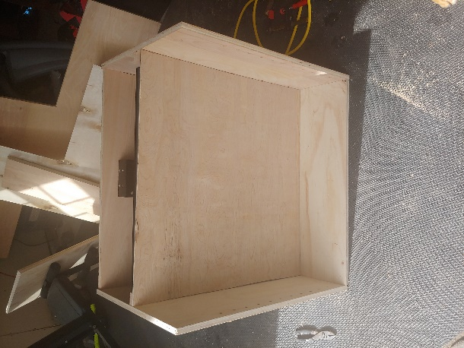
Step 5: Now it is time to make the holes for the dowel supports for the shelves. Create a template using a scrap piece of wood that denotes what spaces you want the holes to be. Flip the cabinet onto its size and then place the side of the template on the line drawn in step 6. Using a ¾-inch drill bit make the holes in the side without drilling all the way through the side.
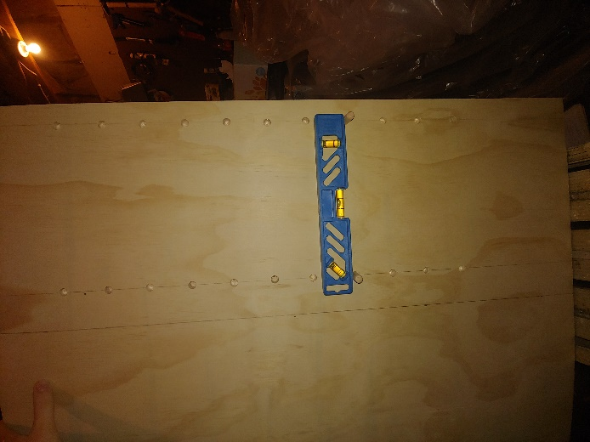
Step 6: Using the parts labeled side trim (1) and (2) from the cut list create the desired design for the side trim.
Step 9: Use a right-angle clamp and the nail gun to attach the shelves front to the actual shelves to make them appear thicker.
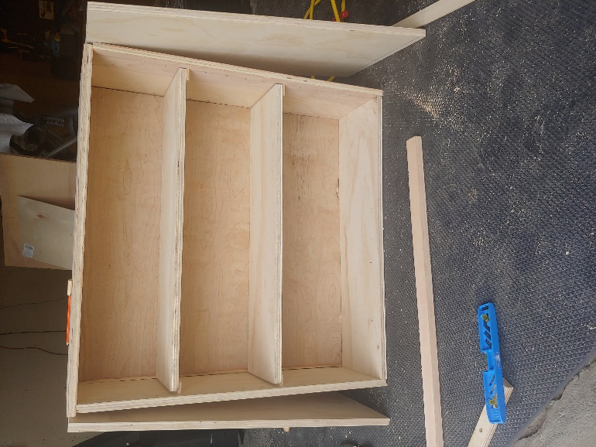
Step 10: Attach the parts labeled door trim (1) and (2) from the cut list to the doors using the nail gun. Then attach the parts labeled door trim insides (1) and (2) once you have them configured how you want them to look. Then using a hinge jig, cut the required holes needed for the hinges to attach to the doors.

Step 11: Finishing step is to add wood filler where you feel is needed and then paint the cabinet the desired colors.

